How to use SUMIF Function when values are not equal to specific criteria
The SUMIF function in Excel is a built-in function used to add up values in a range that meet specific criteria. It allows you to specify a range of cells to evaluate, a condition or criteria to test against, and a range of cells to sum if the corresponding values meet the condition. You would use the SUMIF function with the "not equal to" criteria when you want to sum values in a range that do not match a specific condition. It allows you to exclude certain data from the sum calculation.
Let's consider a practical scenario where you have a dataset of sales transactions for different products, and you want to calculate the total sales amount for all products except a specific product. The following dataset includes names of the products and their sales in USD.
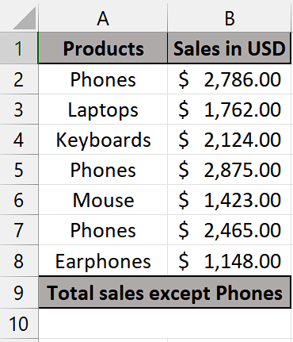
Let's say you want to calculate the total sales amount for all products except "Phones." Follow the simple steps mentioned below to use this function properly:

Step 1 – Selecting the cells
- Select a vacant cell where you wish to apply the SUMIF function.
- This cell will be used to calculate the sum of data except the data we wish to exclude from summation or the values that are not equal to specific criteria by using SUMIF Function.
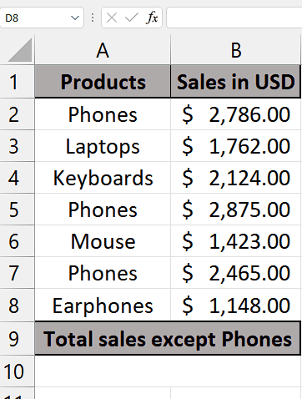

Step 2 – Writing the formula
- In the chosen cell, start by entering the equal sign (=) to initiate the formula.
- Next, type "SUMIF" and use the tab key on your keyboard to select the SUMIF function.
- Then, select the range of cells that will be used to determine which data should be excluded from the summation. This range will be taken as first parameter range. For example, A2:A8 in this case.
- After that, insert a comma (,) to proceed to the second parameter, which is the criteria.
- In this parameter type "<>Phones" (quotes included). This will basically tell us that what values of data don’t meet the criteria should be excluded from the total answer.
- Following that, input another comma (,) to proceed to the third parameter, which corresponds to the sum_range.
- After that enter the range in which the values that are to be summed are present. For example, B2:B8 in this case.
- Now that you have followed all the steps above, your formula would look like this, =SUMIF(A2:A8, "<>Phones", B2:B8
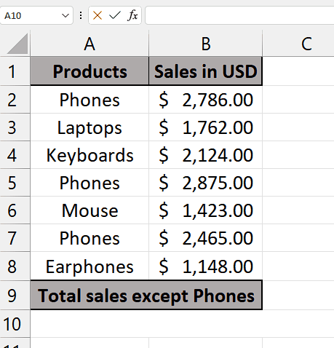

Step 3 – Implementing the formula
- Upon completing the previous step, close the parenthesis and press the Enter key to finalize the formula.
- Now, the data whose values don’t match with criteria will be excluded from the summation of total values.
- For example, we selected that the sales of phones will not be equal to the criteria and we can see that the result is the calculated value of sales of other products except the sales of phones.
